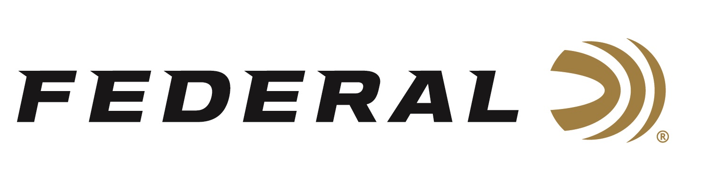

FOR IMMEDIATE RELEASE

Federal Ammunition Introduces New Speed-Shok 100-Packs

ANOKA, Minnesota – March 11, 2020 – Bring the velocity and power of Federal Speed-Shok to the blind in bulk. New Speed-Shok 100-packs come in the most popular payloads, delivering both the performance and convenience high-volume waterfowl hunters need. Shipments of this product have begun to arrive at dealers.

Recently redesigned Speed-Shok loads fill limits faster and cleaner than ever, thanks to the Catalyst primer and faster-burning powders that dramatically reduce residue. Each easy-to-transport 100-count case pack with handle contains four 25-round boxes.

Features & Benefits
- Convenient 100-count bulk packs
- Faster-burning, cleaner propellant leaves drastically less residue in the barrel and action
- Catalyst high-performance lead-free primer provides the most complete, consistent ignition possible
- Optimized velocities

Part No. / Description / MSRP
WF142100 2 / 12 gauge 3 inch 1 ¼ ounce 2, 100 count / $64.99
WF142100 4 / 12 gauge 3 inch 1 ¼ ounce 4, 100 count / $64.99
WF142100 BB / 12 gauge 3 inch 1 ¼ ounce BB, 100 count / $64.99

Federal ammunition can be found at dealers nationwide or purchased online direct from Federal. For more information on all products from Federal or to shop online, visit www.federalpremium.com.

Press Release Contact: JJ Reich
Senior Manager – Press Relations
E-mail: VistaPressroom@VistaOutdoor.com

About Federal Ammunition
Federal, headquartered in Anoka, MN, is a brand of Vista Outdoor Inc., an outdoor sports and recreation company. From humble beginnings nestled among the lakes and woods of Minnesota, Federal Ammunition has evolved into one of the world's largest producers of sporting ammunition. Beginning in 1922, founding president, Charles L. Horn, paved the way for our success. Today, Federal carries on Horn's vision for quality products and service with the next generation of outdoorsmen and women. We maintain our position as experts in the science of ammunition production. Every day we manufacture products to enhance our customers' shooting experience while partnering with the conservation organizations that protect and support our outdoor heritage. We offer thousands of options in our Federal Premium and Federal® lines-it's what makes us the most complete ammunition company in the business and provides our customers with a choice no matter their pursuit.

